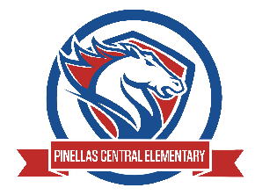

Pinellas Central Elementary School
3rd Grade School Supply List 2025-2026

Abby Cannata, Principal Stephanie Wager, Asst. Principal

Student Items (for individual student use)
- 1 pair of ear buds or headphones – no bluetooth (necessary for computer lab work)
- backpack
- 4 three prong, plastic 2 pocket folders (red, yellow, green, blue)
- 3 composition notebooks
- 4 packs of sticky notes (standard size)
- pencils (standard yellow)
- colored pencils
- glue sticks
Supplemental Classroom Items-Donations Welcome
- hand sanitizer
- tissues
- plastic zipper bags (all sizes but mostly gallon sized)
- wide ruled paper
- dry erase markers (black ink only)

